**UML ASSIGNMENT**

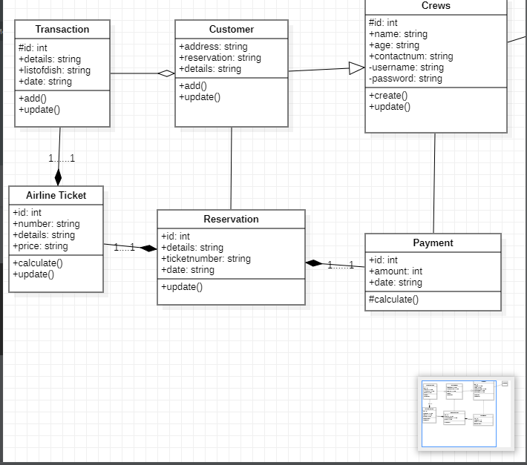

**UML Class Diagram for Airline Management**

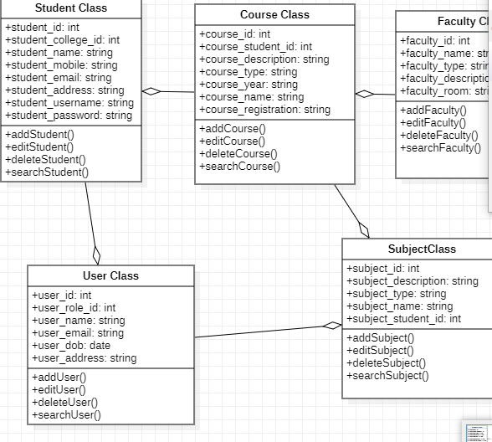

Diagram for Faculty Management System Class

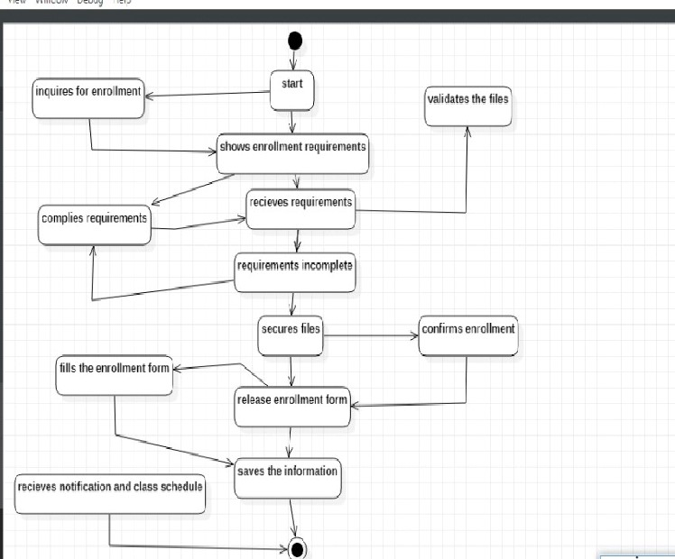

Activity Diagram

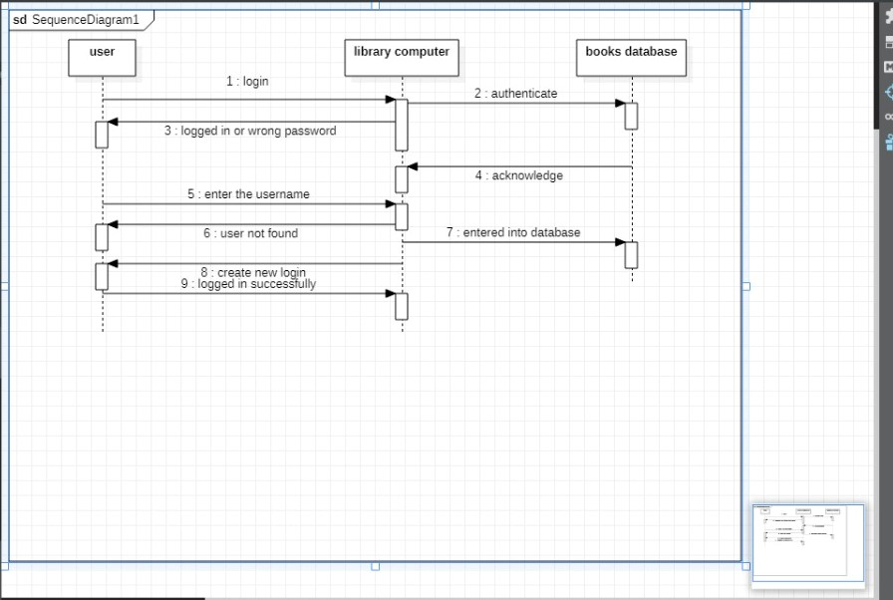

Sequence Diagram